1.Create a backup of your WhatsApp chat history on your Android device, then locate and verify the backup file in your Google Drive or local storage.
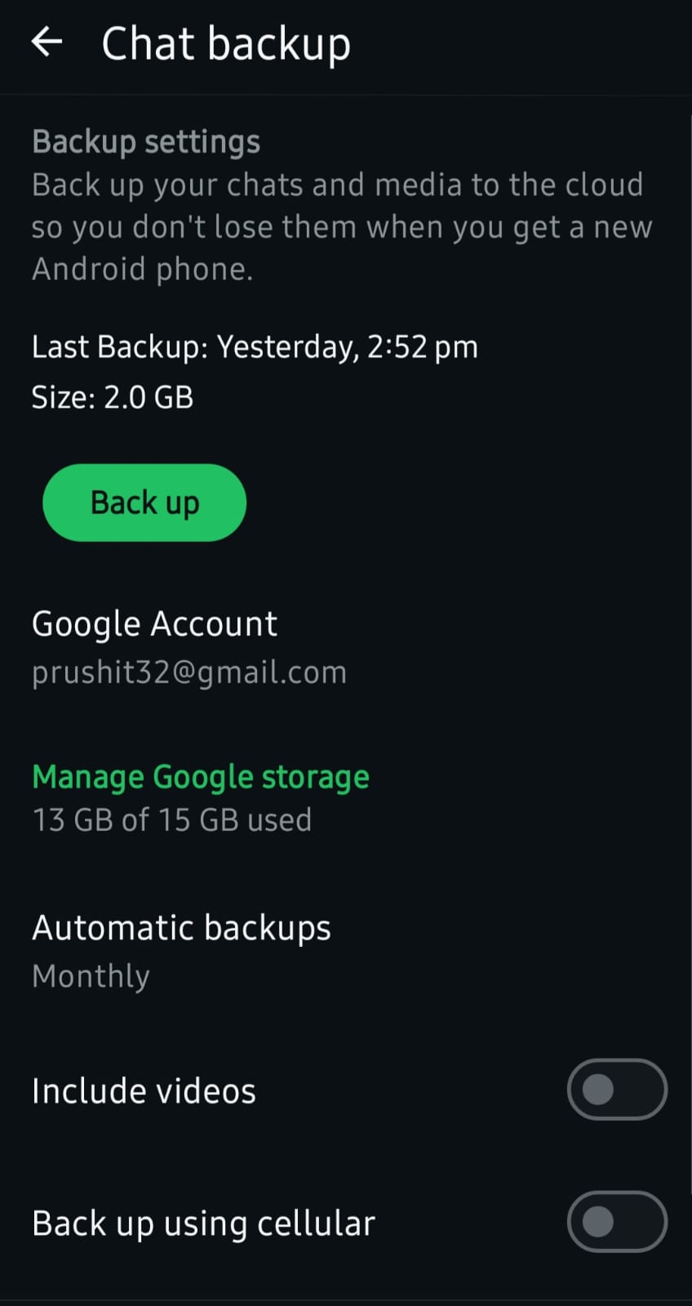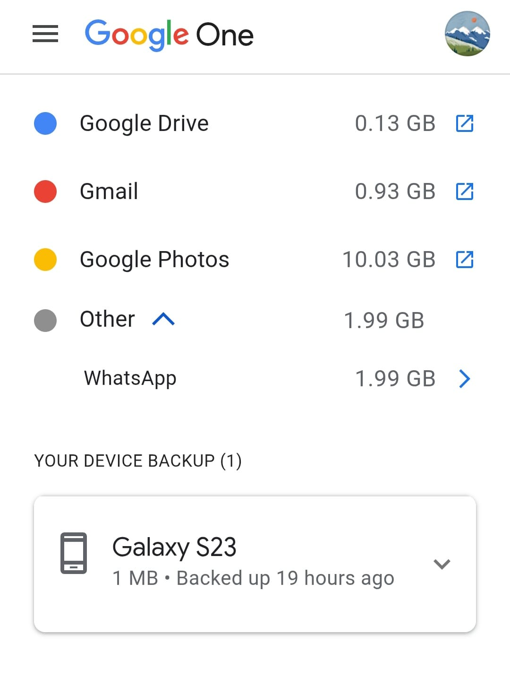
2.Simulate accidental photo deletion by moving 3 images from your phone's gallery to the trash, then restore them using your phone's built-in recovery feature. <br> <br> <em><strong>Hint:</strong> Check the 'Recently Deleted' or 'Trash' folder in your gallery app.</em>
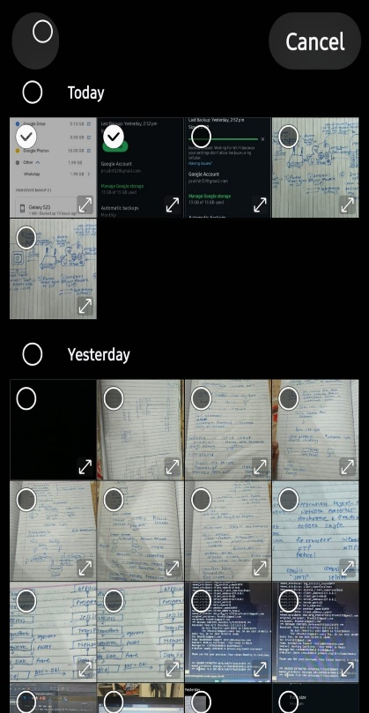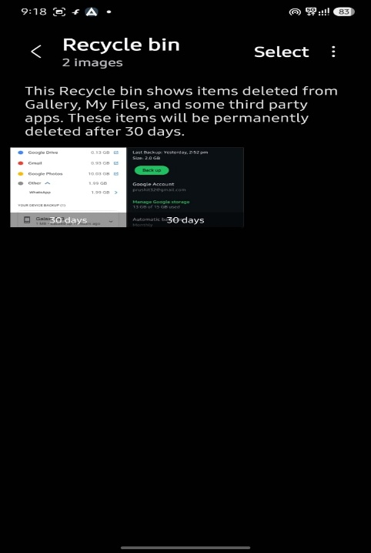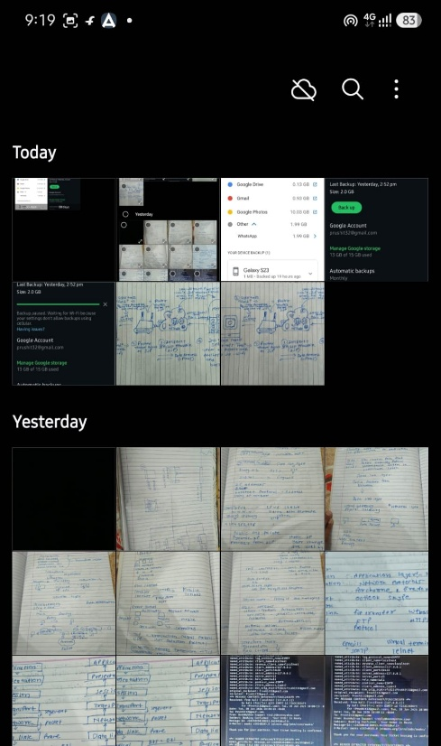
3.Write a step-by-step guide (with screenshots if possible) on how to schedule automatic backups of your contacts to Google Account or iCloud, so you never lose them if your phone is lost.
Option 1: Automatic Backups to Google Account (Android )
Google securely stores your contacts and lets you access them from any device at Google Contacts.
On Android:
- Open the Settings app on your phone.
- Tap Google (or Google services and preferences).
- Scroll down and tap Settings for Google apps.
- Tap Google Contacts sync.
- Ensure Also sync device contacts is toggled ON

4.Use Google Takeout to export and download a backup of your YouTube playlist data, then extract the ZIP and list the names of all playlists you backed up.
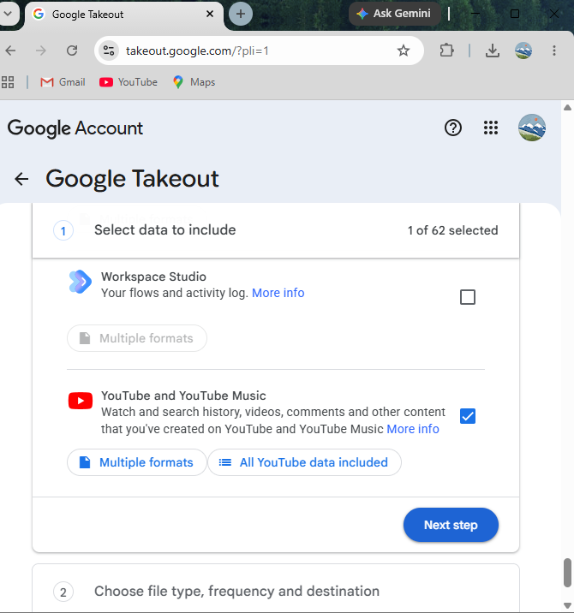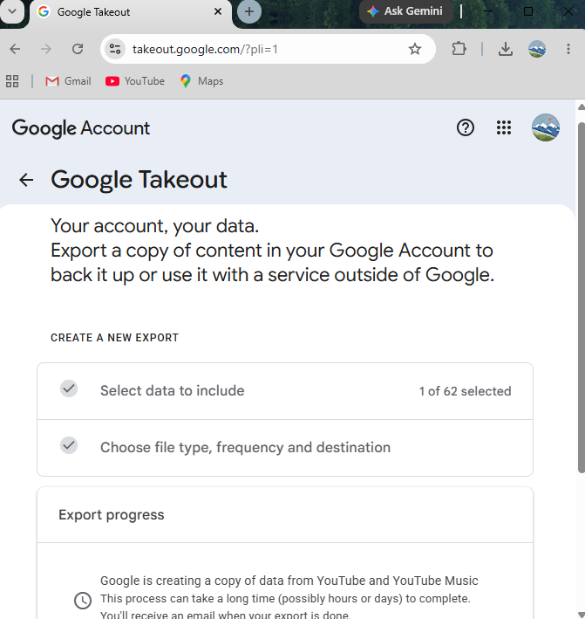
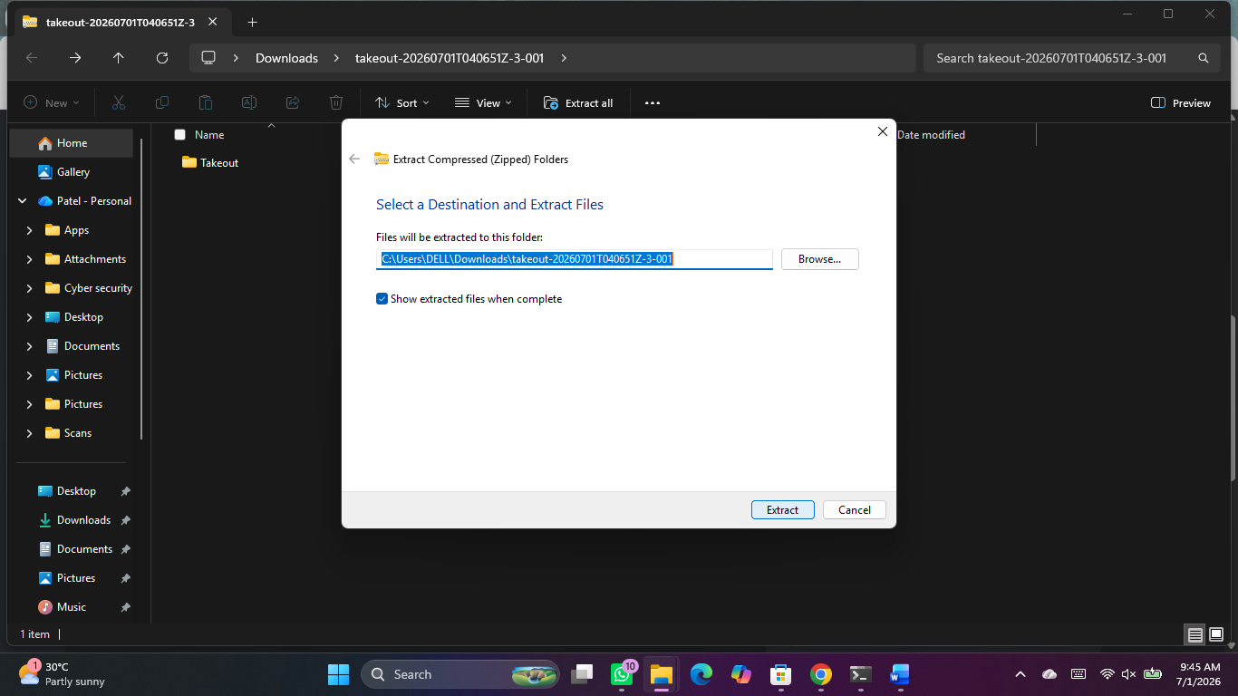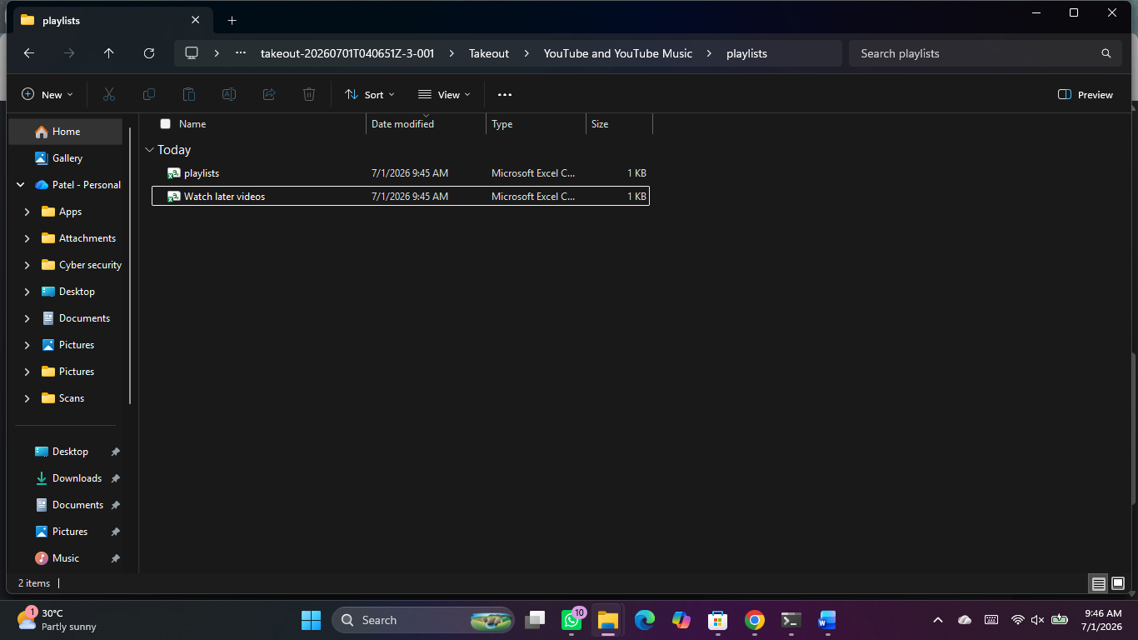
5.Test restoring a deleted file from Google Drive's Trash: upload a sample file, delete it, then recover it from Trash and confirm it's accessible.
To test restoring a deleted file from Google Drive's Trash, you need to upload a sample file, delete it, recover it from the Trash folder, and then verify its accessibility.
Below is the step-by-step procedure to execute this test scenario successfully on a computer:
Step 1: Upload a Sample File
- Go to Google Drive in your web browser.
- Click the New button (+ icon) in the top-left corner.
- Select File upload from the dropdown menu.
- Choose any small sample file from your computer (e.g., test_file.txt).
- Wait for the "Upload complete" notification at the bottom right.
Step 2: Delete the File
- Locate your uploaded file (test_file.txt) in your file list.
- Click the three vertical dots (More actions) next to the file name, or right-click the file.
- Select Move to trash (or click the file and press the Delete key on your keyboard).
- Verify that the file disappears from your main file view.
Step 3: Recover the File from Trash
- Click on Trash from the left-hand navigation panel.
- Locate your file (test_file.txt) inside the Trash folder.
- Right-click the file (or click the three vertical dots next to it).
- Click Restore from the menu options.
Step 4: Confirm File Accessibility
- Click on My Drive in the left panel to return to your main file storage.
- Find the restored file (test_file.txt) in its original location.
- Double-click the file to open it and verify that the content is fully readable and accessible.

